6.3 APQB – Exchange Rate Market
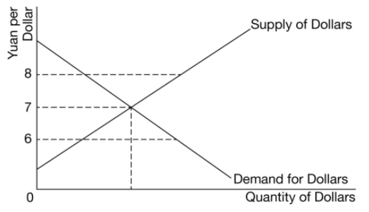
- The diagram shows the United States dollar-Chinese yuan foreign exchange market. If the current exchange rate is 6 yuan per dollar, which of the following describes the current state of the market and how the value of the dollar will change in a flexible exchange-rate system?
- There is a surplus of dollars and the dollar will appreciate.
- There is a surplus of dollars and the yuan will depreciate.
- There is a shortage of dollars and the dollar will appreciate.
- There is a shortage of dollars and the dollar will depreciate.
- There is a shortage of dollars and the yuan will appreciate.
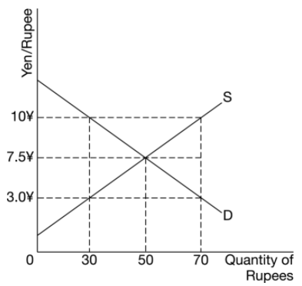
- If one Indian rupee is exchanged for three Japanese yen in the foreign exchange market, which of the following describes the foreign exchange market for Indian rupees?
- There is a surplus of 40 yen.
- There is a surplus of 20 rupees.
- There is a shortage of 20 yen.
- There is a shortage of 40 rupees.
- The foreign exchange market is in equilibrium.
- If the current exchange rate of the Mexican peso and the Brazilian real is 0.20 real per peso, and the equilibrium exchange rate is 0.18 real per peso, which of the following describes the foreign exchange market for the Mexican peso?
- There is a shortage of pesos and the peso will appreciate.
- There is a shortage of pesos and the peso will depreciate.
- There is a surplus of pesos and the peso will appreciate.
- There is a surplus of pesos and the peso will depreciate.
- There is a surplus of pesos and the real will depreciate.
- Which of the following is true if exchange rates are freely floating?
- The free market forces of demand and supply determine the equilibrium exchange rates.
- The demand curve for the currency is upward sloping.
- Only nominal values of currency can be determined.
- The market determines the equilibrium value of the currency, but governments buy and sell currency at a fixed rate.
- Governments are unable to affect the international value of their currency.
- If consumers in Canada increase their demand for products that are manufactured in India, which of the following will occur?
- The Indian rupee will depreciate.
- The Canadian dollar will appreciate.
- India’s financial capital inflow will increase.
- Canada’s financial capital inflow will increase.
- The supply of Canadian dollars will decrease.

Answer
1. C 2. D 3. D 4. A 5.D

